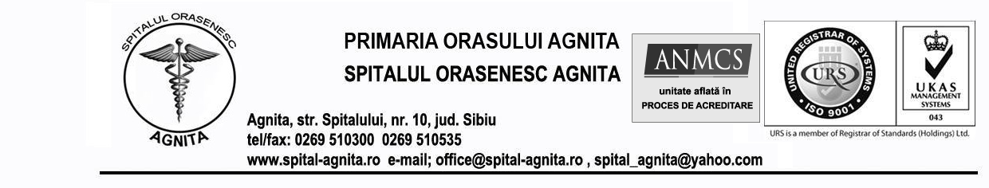
LISTA ANALIZE MEDICALE EFECTUATE LA LABORATORUL DE ANALIZE MEDICALE AL SPITALULUI ORASENESC AGNITA
Nr. crt. | ANALIZE MEDICALE | TARIF (LEI)
1 | HEMOGRAMA AUTOMATA | 18
2 | FORMULA LEUCOCITARA ( FROTIU ) | 12
3 | V.S.H. | 6
4 | TIMP DE SANGERARE ( TS ) | 6
5 | TIMP DE COAGULARE ( TC ) | 6
6 | APTT | 15
7 | TIMP DE PROTROMBINA ( TQ- INR ) | 18
8 | FIBRINOGEN | 17
9 | GRUP SG. OAB | 13
10 | GRUP SG. R. H. | 13
11 | GLICEMIE | 8
12 | UREE | 10
13 | CREATININA | 10
14 | COLESTEROL | 8
15 | HDL - COLESTEROL | 10
16 | LDL COLESTEROL | 8
17 | TRIGLICERIDE | 8
18 | TGO | 10
19 | TGP | 10
20 | ACID URIC | 10
21 | PROTEINE TOTALE | 10
22 | FOSFATAZA ALCALINA ( FAS ) | 10
23 | CALCIU SERIC TOTAL | 10
24 | CALCIU IONIC | 10
25 | MAGNEZIU SERIC | 10
26 | GGT | 10
27 | BILIRUBINA ( BT, BD ) | 12
28 | GLICOZURIE | 8
29 | RPR | 15
30 | T.P.H.A. | 15
31 | ASLO | 12
32 | PROTEINA C REACTIVA ( PCR ) | 13
33 | FACTOR REUMATOID ( FR ) | 13
34 | EXAMEN COMPLET URINA | 15
35 | SUMAR URINA ( FARA SEDIMENT ) | 10
36 | SEDIMENT | 5
37 | UROBILINOGEN SI PIGMENTI BILIARI | 6
38 | EXAMEN COPROPARAZITOLOGIC | 12
39 | SECRETIE VAGINALA | 12
40 | R. ADLER | 8
41 | FIER | 10
42 | ATG HBs – TEST RAPID | 12
43 | ATC anti HCV – TEST RAPID | 12
44 | TEST HIV – TEST RAPID

Manager, Medic Laborator Analize,
ec.Prisca Iosif Nicolae dr.Marginean Rodica

